**JEEVAN – AN ONLINE BLOOD DONOR WEB APPLICATION**

**A PROJECT REPORT**

***Submitted to***



**ASSAM DON BOSCO UNIVERSITY**

***by***

**VARGAB DAS**

**DC2018BCA0049**

**NIKITA DAS**

**DC2018BCA0041**

**EJAJ KHAN**

**DC2018BCA0055**

***in partial fulfilment for the award of the*** ***degree***

***of***

**BACHELOR OF COMPUTER APPLICATIONS**

**DEPARTMENT OF COMPUTER APPLICATIONS**

**SCHOOL OF TECHNOLOGY, ASSAM DON BOSCO UNIVERSITY**

**AZARA, GUWAHATI 781 017, ASSAM, INDIA.**

**BATCH (2018 - 2021)**

**CERTIFICATE**

This is to certify that the Project Report entitled **JEEVAN – AN ONLINE BLOOD DONOR WEB APPLICATION** submitted by **VARGAB DAS (DC2018BCA0049), NIKITA DAS (DC2018BCA0041) and EJAJ KHAN (DC2018BCA0055)** to the Assam Don Bosco University, Guwahati, Assam, in partial fulfilment of the requirement for the award of Degree of Bachelor of Computer Applications is a bonafide record of the project work carried out by them under my supervision during the semester September 2020 to January 2021.

Internal Guide:

Mr. Alexy Bhowmick

Assistant Professor (II)

Department of Computer Science Engineering

School of Technology

Assam Don Bosco University

**CERTIFICATE**

This is to certify that the Project Report entitled **JEEVAN – AN ONLINE** **BLOOD DONOR WEB APPLICATION.** Submitted by **VARGAB DAS** **(DC2018BCA0049), NIKITA DAS (DC2018BCA0041) and EJAJ KHAN (DC2018BCA0055)** to the Assam Don Bosco University, Guwahati, Assam, in partial fulfilment of the requirement for the award of Degree of Bachelor of Computer Applications is a bonafide record of the project work carried out by them during the semester July 2019 to December 2019.

Dr. Pranab Das

Head of the Department,

Department of Computer Applications

Date: .........................

**EXAMINATION CERTIFICATE**

This is to certify that **VARGAB DAS**, **NIKITA DAS** and **EJAJ KHAN** bearing Roll Numbers **DC2018BCA0049,** **DC2018BCA0041** and **DC2018BCA0055** respectively of the **Department of Computer Applications** has carried out the project work in a manner satisfactory to warrant its acceptance and also defended it successfully.

We wish them all the success in their future endeavours.

Examiners:

1. Internal Examiner:

1. Internal Examiner:

**DECLARATION**

We hereby declare that the project work entitled **JEEVAN – AN ONLINE BLOOD DONOR WEB APPLICATION** submitted to the Assam Don Bosco University, Guwahati, Assam, in partial fulfilment of the requirement for the award of Degree of Bachelor of Computer Applications is an original Work done by us under the guidance of **Mr. Alexy Bhowmick** (*Asst. Professor, ADBU Department of Computer Science & Engineering, School of Technology Assam Don Bosco University)* and has not been submitted for the award of any degree.

(Signature of the student)

**VARGAB DAS**

**DC2018BCA0049**

**Department of Computer Applications School of Technology,**

**Assam Don Bosco University**

(Signature of the student)

**NIKITA DAS**

**DC2018BCA0041**

**Department of Computer Applications School of Technology,**

**Assam Don Bosco University**

(Signature of the student)

**EJAJ KHAN**

**DC2018BCA0055**

**Department of Computer Applications School of Technology,**

**Assam Don Bosco University**

**ACKNOWLEDGEMENT**

Words are not just enough to express our gratitude but we take this opportunity to express our profound sense of gratitude and respect to all those who helped us throughout the duration of this project

We acknowledge the effort of those who have contributed significantly to our project. First of all, we are very thankful to our parents for their regular support and guidance. We are also very thankful to our college for providing us an opportunity to do this particular project Special thanks to HOD of the Department of Computer Applications. Dr. Pranab Das for letting us work on a project of this magnitude and providing assistance whenever needed.

A very sincere gratitude to our project coordinator, Miss Usha Mary Sharma for her constant support and guidance. We feel privileged to offer our sincere thanks and deep sense of gratitude to Mr. Alexy Bhowmick, project guide for expressing his confidence in us by his continuous support, help and encouragement in implementing this project.

**ABSTRACT**

The problem of finding appropriate blood donor and blood banks has been a critical one which has caused the loss of precious lives. The inability of quick and efficient access to blood donors to suit the patients needless cost time, effort and human lives. This project was created with the goal of finding a possible solution to this dire problem. The web application is made using HTML 5, CSS, Bootstrap (v5.0.0) and Ajax (v3. 2) for the front-end, Firebase - Firestore (v8. 2.1) as database, JavaScript (ES6) for back-end and Google API for map. Using these technologies, we were able to design a responsive, scalable and user-friendly web solution to create a platform for user, donors and patients, to effectively connect with each other. Making our website mobile friendly will also allow a broader scope of users access to our features and a UI designed with the end user in mind allows our website to perform in a more user centric manner.

**Keywords**: *Blood Donor, Blood Bank, HTML, CSS, JavaScript, Bootstrap, Firebase.*

**LIST OF TABLES**

**Table _Title ___ _____________ _________________ ___Page**

2.2.1 Software Requirements 18

2.2.2 Hardware Requirements 18

2.3.1 COCOMO Model Coefficient Values 19-20

**LIST OF FIGURES**

**Figure Title ____________________________________Page**

1.4.1.1 Homepage of Friends2support Website 5

1.4.1.2 Find Blood Donor feature of Friends2support Website 5

1.4.1.3 Donor Registration feature of Friends2support Website 6

1.4.2.1 Home Page of Blood Bank Today website 7

1.4.2.2 Find Blood Donor feature of Blood Bank Today website 8

1.4.2.3 Donor Registration feature of Blood Bank Today website 8

1.4.3.1 Homepage of Indian Blood Donorwebsite 9

1.4.3.2 Donor Registration feature of Indian Blood Donor website 10

1.4.4.1 Homepage of E-Rakt Kosh website 11

1.4.4.2 Find Blood Banks Feature of E-Rakt Kosh website 12

1.4.4.3 Donor Registration Feature of E-Rakt Kosh website 12

2.4.1 Work Breakdown Structure 22

2.4.2 Gantt Chart 23

3.1 Use Case Diagram 24

3.2 Activity Diagram 25-27

3.3 Class Diagram 28

4.1 Homepage of “JEEVAN - Online Blood Donor Website” 30

4.2 Survey of “JEEVAN - Online Blood Donor Website” 31

4.3 Donor Register of “JEEVAN - Online Blood Donor Website” 32

4.4 Ineligible for donor registration “JEEVAN - Online Blood Donor Website” 32

4.5 Patient Registration of “JEEVAN - Online Blood Donor Website” 33

4.6 Blood Categories page of “JEEVAN - Online Blood Donor Website” 34

4.7 Donors List page of “JEEVAN - Online Blood Donor Website” 35

4.8 Filter Donors by Available 35

4.9 Filter Donors by Locality 36

4.10 Post Blood Request page of “JEEVAN - Online Blood Donor Website” 36

4.11 Finding nearest blood bank 37

4.12 Blood Requests display page of “JEEVAN - Online Blood Donor Website” 37

4.13 Donor/Patient/Admin Log In of “JEEVAN - Online Blood Donor Website” 38

4.14 Profiles of donor & patients of “JEEVAN - Online Blood Donor Website” 38

4.15 Admin monitoring donors and patients 39

4.16 Admin monitoring blood requests. 39

4.17 Donor Registration Validation 40

4.18 Patient Registration Validation 41

4.19 Log-in Page Validation 42

4.20 Homepage Mobile View 43

4.21 Donor Registration Mobile View 44

4.22 User Profile Mobile View 44

**CONTENTS**

**List of tables**  i

**List of figures** ii-iv

**Chapter 1:- Introduction**

1.1 Project Title 1

1.2 Objective 1

1.3 Introduction 2-3

1.4 Study of the Existing System 4-12

1.5 Limitations of the Existing System 13

1.6 Features to be included in the system 14-16

**Chapter 2:-Feasibility Study & Requirement Analysis**

2.1 Feasibility Study 17

2.2 Technical Feasibility 18

2.2.1 Software Requirements 18

2.2.2 Hardware Requirements 18

2.3 Economic Feasibility 19

2.3.1 COCOMO Model 19-20

2.4 Scheduled Feasibility 21-23

2.4.1 Work Breakdown Structure 21-22

2.4.2 Gantt Chart 23

2.5 Operational Feasibility 23

**Chapter 3:- Design Diagrams**

3.1 Use case Diagram 24

3.2 Activity diagram 25-27

3.2.1 Patient Login Activity Diagram 25

3.2.2 Donor Login Activity Diagram 25

3.2.3 Activity Diagram for Admin 26

3.2.4 Register as Donor or Patient Activity Diagram 26

3.2.5 Activity Diagram to Search for Nearby Blood Banks 27

3.2.6 Activity Diagram for Searching Donor 27

3.2.7 Activity Diagram for Posting Blood Request 27

3.3 Class diagram 28

**Chapter 4:- Implementation** 29

4.1. Homepage 29-30

4.2. Survey form 31-33

4.3. Choose Blood Category 34-36

4.4. Login Page 37-38

4.5. Validation 39-41

4 .6 Below figures shows what our website looks in mobile view 43-44

**Chapter 5:- Conclusion** 42

5.1 Summary 42

5.2 Future Scope 42

**References** 43-45

# CHAPTER 1

# INTRODUCTION

**1.1. PROJECT TITLE:**

JEEVAN - An Online Blood Donor Web Application

**1.2. OBJECTIVE:**

The objective of this project is to develop a website to streamline the process of blood donation for patients in immediate need. The system will enable fluid communication between blood donors & patients taking into consideration all the criteria specified by the patient namely blood type, quantity, etc. The main objectives of the system are outlined below:

1) To enable donors to register themselves for blood donations on to the system.

2) To enable patients to get quick and efficient access to blood donations by simple searches on the website.

3) To create a website that better organizes and streamlines the blood donation and blood receiving process.

**1.3. INTRODUCTION**

#### Blood donations and finding blood donors is a very complicated and time-consuming process for both the patient and their next of kin. In many cases, patients die because of not receiving appropriate blood donation on time. Currently, information for blood donations is managed wholeheartedly by hospitals and blood banks with normal patients unaware of how to properly procure the blood donation.

#### In some cases, blood banks may not carry the required type or units of blood. In the present scenario, people have to go to blood banks to find their required blood donation which is complicated & time-consuming. In cases of unavailability of the required blood type in hospitals or blood banks, the patient next of kin must resort to informal and unorganized means of acquiring the necessary blood donations, they may also turn to social media in case of emergency. These information methods are rarely effective and also risk the patient’s life.

#### The project aims to develop an organized platform to allow donors and patients to communicate and arrange proper blood donations in time for those who need it. With the help of this website patient’s families can easily post blood requests, search and locate the appropriate donor and contact them via their various contact details namely contact number, address, social media handles.

We have decided to develop a web application and not a mobile application of the same for the following reasons:

A website can be universally accessed from any phone with an internet connection and a browser while the same cannot be said for an application that is developed for specific operating systems. Using a website allows us to cover a greater span of consumers. Also our web application will be designed to be mobile - friendly. Using an app puts storage overhead on the device which is undesirable for people who have low budget phones with lower memory capacity. Using a website allows us to negate that overhead.

JEEVAN - The Online Blood Donor website will be easily available to everyone. When a person wants to donate blood he/she has to register on the website. Donor registration is very simple, to get registered to the website he/she has to fill up a registration form containing the following i.e. his/her name, age, blood group, contact details, address, etc. After submitting the registration form he/she can create a username and password. A donor can also change his account information when he wants to use his username and password.

**1.4. STUDY OF THE EXISTING SYSTEM**

As part of our initial research, we decided to investigate applications that offer the same or similar services.

**1.4.1. Friends2support.org**

**Description of Friends2support –**

1. "Friends2support" is an organization that brings voluntary blood donors and those in need of blood to a common platform. Through this website, they seek donors who are willing to donate blood, as well as provide the timeliest support to those in frantic need of it.
2. Their mission is to fulfil every blood request in the country with a promising web portal and motivated individuals who are willing to donate blood.
3. The Features that the website provides are:

* Blood Donor Login/Register
* Find blood donor
* Post blood request
* Displays latest news on their homepage
* Displays Current Blood Requests on their homepage

Homepage –

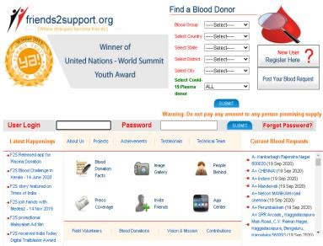

Fig: 1.4.1.1 Homepage of Friends2support Website

Find Blood Donor –

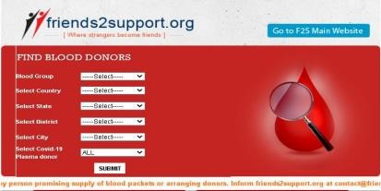

Fig: 1.4.1.2 Find Blood Donor feature of Friends2support Website

Donor Registration –

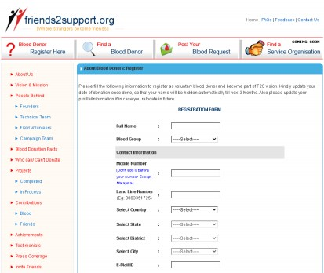

Fig: 1.4.1.3 Donor Registration feature of Friends2support Website

* + 1. **Blood Bank Today**

**Description of Blood Bank Today –**

1. "BloodBankToday" is an organization that brings voluntary blood donors and those in need of blood onto a common platform.
2. Through this website, they tie-up with blood banks and provide the timeliest support to those in frantic need of it.
3. Features that this website provides are:

* Blood Donor Login/Register
* They have tied up with blood banks to provide blood to the patients in need.
* Donate to the blood bank
* Displays current donor join on their homepage
* Can request a donation for any crisis cause/event.

Find a blood donor –

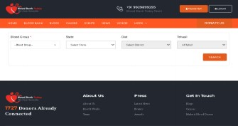

Fig: 1.4.2.1 Find Blood Donor feature of Blood Bank Today website

Homepage -

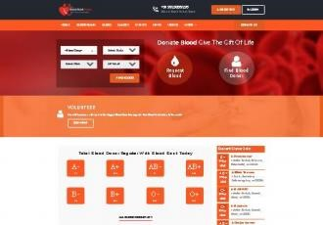

Fig: 1.4.2.2 Home Page of Blood Bank Today website

Donor Registration –

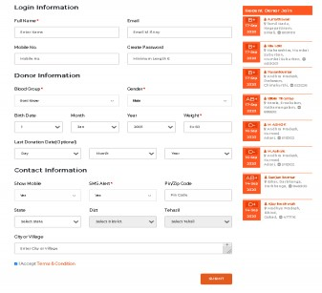

Fig: 1.4.2.3 - Donor Registration feature of Blood Bank Today website

**1.4.3. Indian Blood Donors**

**Description of Indian Blood Donors -**

1. In this website the patient in need , has to utilize the Donors name and Telephone number provided and contact the donor for blood donation.
2. The details of the donors are given only to facilitate the users for contacting them when in need of blood in case of any emergency.
3. They cannot post blood requests.
4. No connection with blood banks.
5. Features that this website provides are:

* Blood Donor Login/Register
* News on homepage
* Include posters for awareness

Homepage -

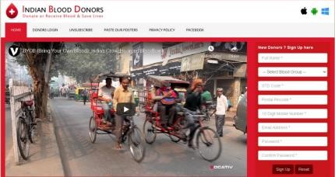

Fig: 1.4.3.1 Homepage of Indian Blood Donor website

Donor Login -

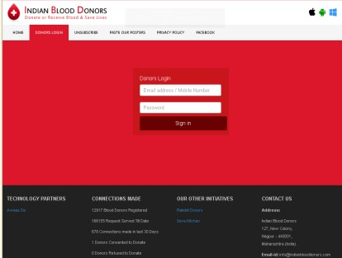

Fig: 1.4.3.2 Donor Registration feature of Indian Blood Donor website

**1.4.4. Eraktkosh**

**Description of e-Rakt Kosh -**

1. E-Rakt Kosh ensures proper collection & donation, effective management, and monitoring of the quality and quantity of the donated blood.
2. Considering the national roll-out, e-Rakt Kosh has been developed with a modular and scalable approach with configurable rule-based architecture allowing customization to easily incorporate specific requirements from nationwide stakeholders.
3. Features that this website provides are:

* Blood Donor Login/Register
* Search nearby blood banks
* Statistic of nationwide blood donations
* Information about compatible blood type donor
* Notification about important days and occasions
* Check blood availability.

Homepage -

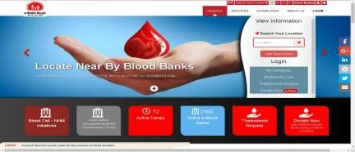

Fig: 1.4.4.1 Homepage of E-Rakt Kosh website

Find blood banks –

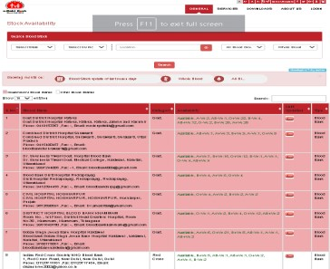

Fig: 1.4.4.2 Find Blood Banks Feature of E-Rakt Kosh website

Donor Registration –

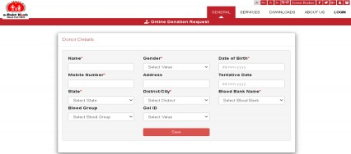

Fig: 1.4.4.3 Donor Registration Feature of E-Rakt Kosh website

**1.5. LIMITATIONS OF EXISTING SYSTEM**

* Some of these blood donor websites do not have the feature of direct interaction between the patient and the donor.
* Some of these blood donor websites do not include the feature to post blood requests
* Some of these blood donor websites do not include the feature to search nearby blood banks.
* Some of these blood donor websites do not include any latest updates about blood requests, recent blood donors, news, and important days/occasions.
* Some of the blood donor websites do not include proper information about blood.
* Compatibility and knowledge about blood donation.

**1.6. FEATURES TO BE INCLUDED IN THE SYSTEM**

Tool used for development: Visual Studio Code (https://code.visualstudio.com/)

Current Trends in Web-Design:

* Dark mode
* Full-page headers
* Dynamic scrolling
* Ultra-minimalist navigation
* Playful cursors
* Custom illustrations

From the Current Trends in Web design we are using the full page headers, dynamic scrolling, and

Ultra-minimalist navigation for the website.

Design inspiration of UI: Website design templates from Dribbble,

(https://dribbble.com/tags/website_template)

Making the website Mobile Friendly: We will make our website mobile friendly by following the certain criteria’s:

* By using Responsive Web design.
* Optimizing Image Size
* Eliminating pop-ups
* Making buttons size large
* Using larger font size.

1. **Homepage** – A home page is a web page that serves as the starting point of a website. On our homepage there will be two options - Donor and Patient, users will choose his/her type accordingly and will be redirected to the following page where either he/ she can login as a donor or as a patient. The homepage also has a navigation menu and a Login button where the donor, patient and admin can login to their profiles also there is a view blood request button which once clicked will show the patients’ blood requests. Our homepage consist of the following features:
   * Donor / Patient (Register/Sign in)
   * Donor / Patient/ Admin (Login)
   * Current Blood Requests
2. **Donor** - In our web Application the donor can register himself/herself to donate blood so that the patients who are in need of blood can contact the registered donor. He/ She have to complete a survey to check whether he/ she are eligible to be a donor. The donor page consist of the following features:
   * Create a profile/log in
   * Complete a survey to check eligibility
   * Enter required information
   * Set as Available/Unavailable
   * Accept / Respond to Blood request
3. **Patient** - In our web application the patient or their next of kin can find blood donors of the particular blood group they are looking for. The patient has to register/login to the website and then choose the blood group according to his/ her requirements from the website’s blood group category. If the patient does not find the required blood group he/she is searching for, he/she can post a blood request to our website's post blood request section which can be viewed by the donors and they can respond to the request accordingly. And we have also kept an option for the patient to search for the nearby blood banks and contact. Our Patient page consist of the following features:
   * Create a profile/log in
   * Select blood group
   * Select donor
   * Contact donor
   * Post blood request
   * Search for nearby blood banks
4. **Post blood request** – Post blood request is a feature that allows the patients in need of blood to post a blood request in the website's post blood request section which can be viewed by the donors and they can respond to the request accordingly and contact. The blood request post contains - required blood group, quantity, date of requirement, address, contact number, etc.

**CHAPTER 2**

# FEASIBILITY STUDY & REQUIREMENT ANALYSIS

# 2.1. FEASIBILITY STUDY

# The feasibility study is an evaluation and analysis of the potential of a proposed project which is based on extensive investigation and research to support the process of decision making. A feasibility study looks at the viability of the project focusing on identifying problems within the project and answering questions like:

1. Is the project technically feasible?
2. Is it feasible within the estimated cost?

Information on the resources available, cost estimation, manpower needed for software development, benefits to the organization after development, and maintenance costs are considered in the feasibility study. The various types of feasibility considered are economic feasibility, technical feasibility, operational feasibility, and schedule feasibility.

**2.2. TECHNICAL FEASIBILITY:**

##### 2.2.1. SOFTWARE REQUIREMENTS

|  |  |
| --- | --- |
| OS | Windows 10 64-bit |
| Platform | HTML 5, JavaScript ES6, CSS, Bootstrap 5.0.0. , Ajax 3.2 |
| Database | Firebase - Firestore 8.2.1 |

Table: 2.2.1 Software Requirements for “JEEVAN - Online Blood Donor Website”

###### 2.2.2. HARDWARE REQUIREMENTS

|  |  |
| --- | --- |
| Processor | Intel Pentium P6200 @ 2.13 GHz |
| RAM | 4.00 GB |
| Hardware Disk Space | 512 GB |

Table: 2.2.2 Hardware Requirements for “JEEVAN - Online Blood Donor Website”

#### 2.3. ECONOMIC FEASIBILITY

#### The purpose of the economic feasibility assessment is to determine the positive economic benefits to the organization that the proposed system will provide. It includes quantification and identification of all the benefits expected.

This assessment typically involves a cost/ benefits analysis.

##### 2.3.1. COCOMO Model

##### The Basic COCOMO model is a static, single-valued model that computes software development effort (and cost) as a function of program size expressed in estimated lines of code (LOC).

COCOMO Model Constructive Cost Model (COCOMO)

The basic COCOMO equations take the form:

Effort Applied (E) =ab(KLOC)bb, [person-months]

Development Time (D) - cb(Effort Applied)bd[months]

People Required (P) = Effort Applied/Development Time [Count].

Where KLOC is the estimated number of delivered lines (expressed in thousands) of code. The coefficients ab, bb, Cb, and db are given in the following table:

|  |  |  |  |  |
| --- | --- | --- | --- | --- |
| Software Project | A  b | b  b | C  b | d  b |
| Organic | 2.4 | 1.05 | 2.5 | 0.38 |
| Semi-detached | 3.0 | 1.12 | 2.5 | 0.35 |
| Embedded | 3.6 | 1.20 | 2.5 | 0.32 |

Table: 2.3.1 COCOMO MODEL coefficient values

Our project type is Organic project, Estimate LOC = 2000

Now the basic COCOMO equation of our project is

Effort Applied (E) = ab (KLOC) bb [person-months]

= 2.4(2K)1.05 [person-months]

= 4.96 [person-months]

Development Time (D) = cb (Effort Applied) db [months]

= 2.5 (4.96)0.38 [months]

= 4.59[months]

People Required (P) = Effort Applied/Development Time [count]

= 4.96 /4.59 [count]

= 1.08 [count] = 1 (approximately)

The projected development time for this project is 4.59 months which will require 1 person. As we have a limited time of approximately 2.5 months to complete this project we will require more people to develop this project.

Since we have 3 members in our group the project development time is justified.

**2.4. SCHEDULED FEASIBILITY**

It is a measure of how reasonable the project timetable is. It is the determination of whether a project can be implemented in the allotted time frame. This is illustrated with the help of the Work Breakdown Structure and Gantt chart provided below.

##### 2.4.1. Work Breakdown Structure

A WBS provides the necessary framework for detailed cost estimating and control along with guiding schedule development and control.

The total project development time (in hours) for our web application is 178 hrs. To further explain the calculation of hours.

Start date of the project = 5 September 2020 End/Submission Date of the project = 13 January 2021

Total number of days = 89 days.

1 day = 2 hours of work.

So now,

Total number of days × Number of hours of work per day

89 days × 2 hours = 178 hours.

Then, we have divided the total hour (178 hrs.) according to the various phases mentioned in the diagram below.

**WBS (Work Breakdown Structure)**

**JEEVAN – ONLINE BLOOD DONOR WEBSITE**

**( 178 HRS )**

**INTEGRATED TESTING**

**( 6 HRS)**

**MODULE TESTING**

**( 6 HRS)**

**UNIT TESTING**

**( 6 HRS)**

**SYSTEM CONCEPTUALIZATION**

**( 6 HRS)**

**DIAGRAMS**

**( 15 HRS)**

**PROJECT PROPOSAL**

**( 20 HRS)**

**DESIGN PHASE**

**( 30 HRS)**

**CODING**

**( 100 HRS)**

**TESTING**

**( 18 HRS)**

**DOCUMENTATION**

**( 10 HRS)**

**RESEARCH AND ANALYSIS**

**( 8 HRS)**

**USER INTERFACE DESIGN**

**( 15 HRS)**

**REQUIREMENT ANALYSIS**

**( 6 HRS)**

Fig: 2.4.1 Work Breakdown Structure for “JEEVAN - Online Blood Donor Website”

**2.4.2. GANTT CHART**

A Gantt chart is a type of bar chart that illustrates the start and finish dates of the terminal elements and summary elements of a project.

Fig: 2.4.2 Gantt chart for “JEEVAN - Online Blood Donor Website”

#### 2.5. OPERATIONAL FEASIBILITY

#### The proposed system is operationally feasible as the final output of the project can be used by the users and it will be easy and user friendly to use. The proposed system does not require special training to operate the web application. This website will fulfil the need for the user in emergency situations.

**Chapter 3**

**DESIGN DIAGRAMS**

## USE CASE DIAGRAM

## A use case diagram at its simplest is a representation of a user's interaction with the system that shows the relationship between the user and the different use cases in which the user is involved. A use case diagram can identify the different types of users of a system and the different use cases and will often be accompanied by other types of diagrams as well. The use cases are represented by either circles or ellipses. Here is the Use Case Diagram of the website:

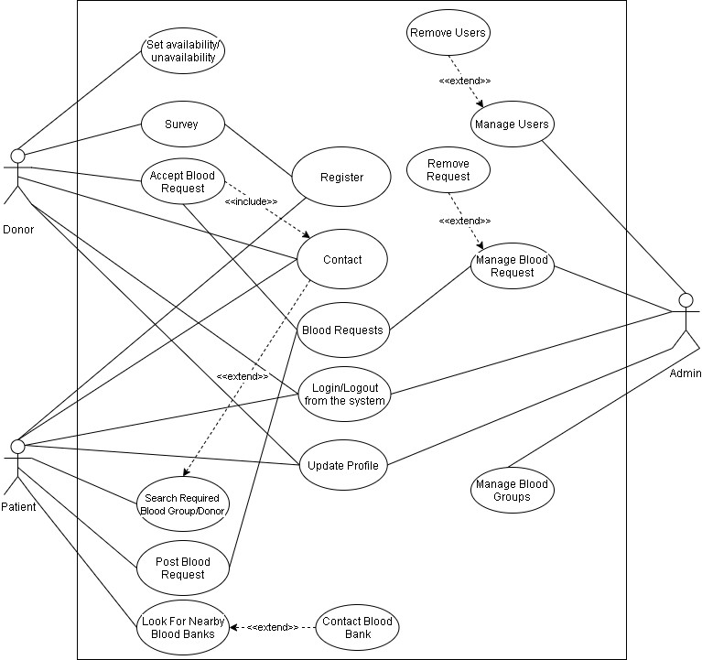

Fig: 3.1 Use Case Diagrams for “JEEVAN - Online Blood Donor Website”

## ACTIVITY DIAGRAM

## An activity diagram is a behavioural diagram i.e. it depicts the behaviour of a system. An activity diagram portrays the control flow from a start point to a finish point showing the various decision paths that exist while the activity is being executed.

Here are the Activity Diagrams of the website:

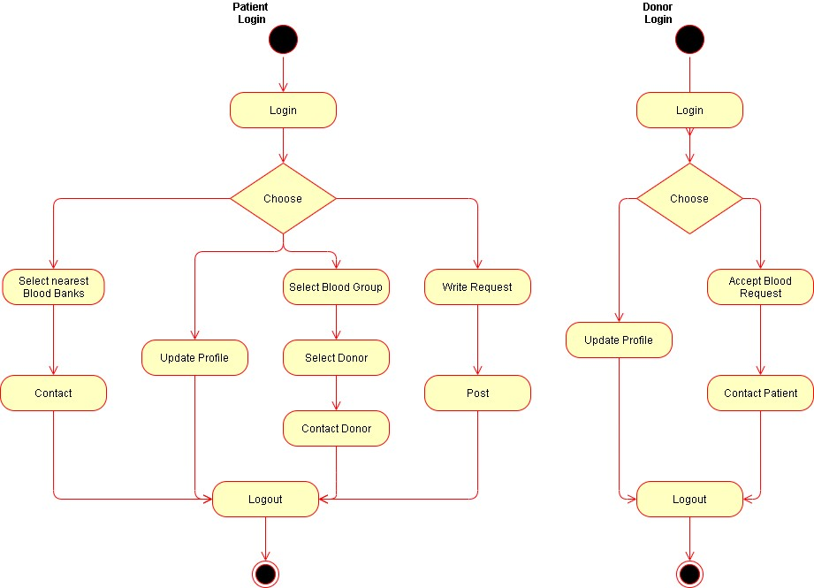

Fig: 3.2.1 Patient Login Activity Diagram Fig: 3.2.2 Donor Login Activity

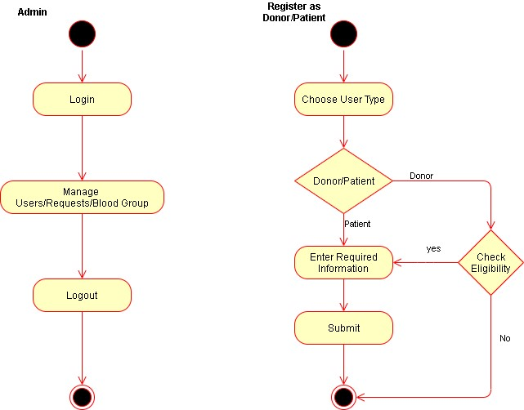

|  |  |
| --- | --- |
|  |  |
| Fig: 3.2.3 Activity Diagram for Admin | Fig: 3.2.4 Register as Donor or Patient Activity Diagram |

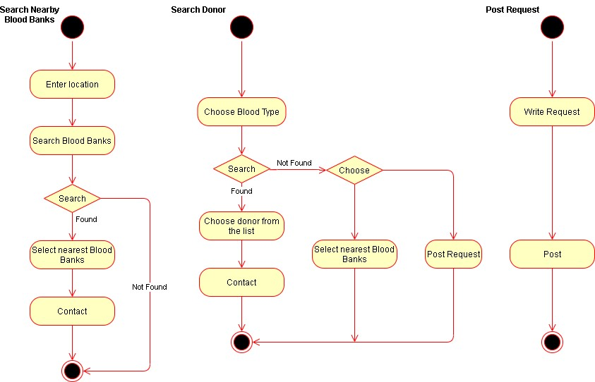

Fig: 3.2.5 Activity Diagram to Fig: 3.2.6 Activity Diagram for Fig: 3.2.7 Activity Diagram Search for Nearby Blood Banks Searching Donor for Posting Blood Request

* 1. **CLASS DIAGRAM**

A class diagram is a type of diagram that describes the structure of a system by showing the system's classes, their attributes, operations (or methods), and the relationships among objects.

Here is the Class Diagram of the website:

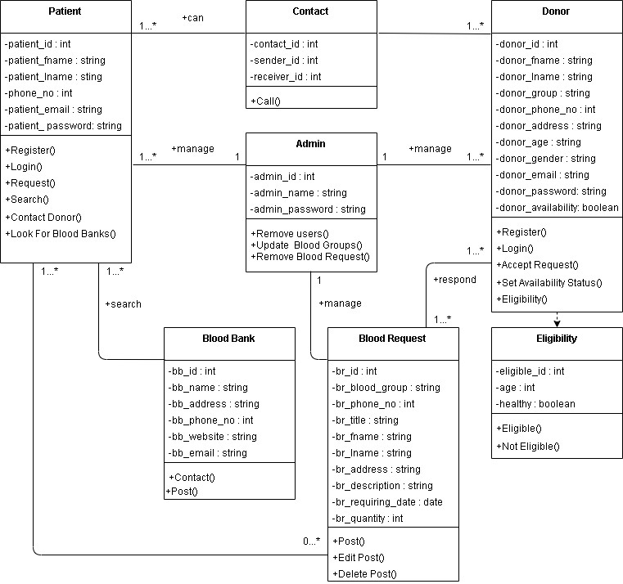

Fig: 3.3 Class Diagram for “JEEVAN - Online Blood Donor Website”

**Chapter 4**

**IMPLEMENTATION**

In our web application – JEEVAN – AN ONLINE BLOOD DONOR WEB APPLICATION we used HTML, CSS, JavaScript, Bootstrap, and Firebase. We used html to design the basic structure and elements of our website. Using html, we were able to design the basic functional features that our users will interact. By implementing a consistent style scheme across our website, we have tried to make it virtually appealing and interactive for the users. This was done with the help of bootstrap and CSS. Using popular fonts, suitable icons and appropriate colour scheme we have made the website more engaging by improving the user’s experience. Our web application makes use of various programs written in JavaScript to provides the features added in our website to the users. Our JavaScript programs communicate with the firebase database on the backend to retrieve and store data as in when needed on request by the user.

**4.1. HOMEPAGE -** **JEEVAN** **AN ONLINE BLOOD DONOR WEB APPLICATION**

We have used html and CSS to design our web application as per the current trend of web development. Our homepage has a minimalistic design with simple iconography to not confuse the users and streamline their usage of the website. By leveraging bootstrap libraries, we have generated a simple navigation bar at the top of the website to help our users to move through the web application easily. From this homepage users can navigate to the most important feature of the website that is to choose the user type and register as a donor or as a patient.

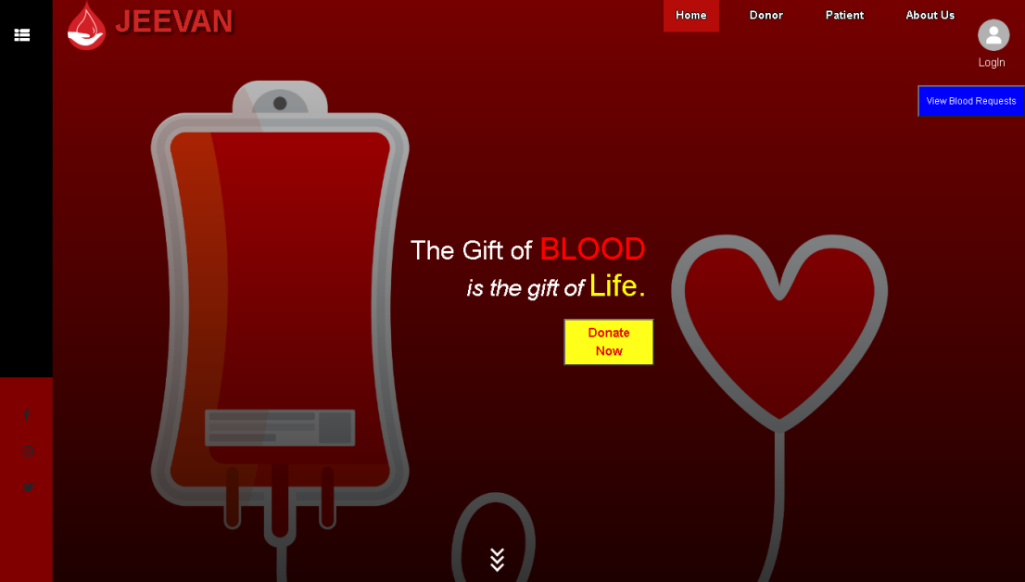

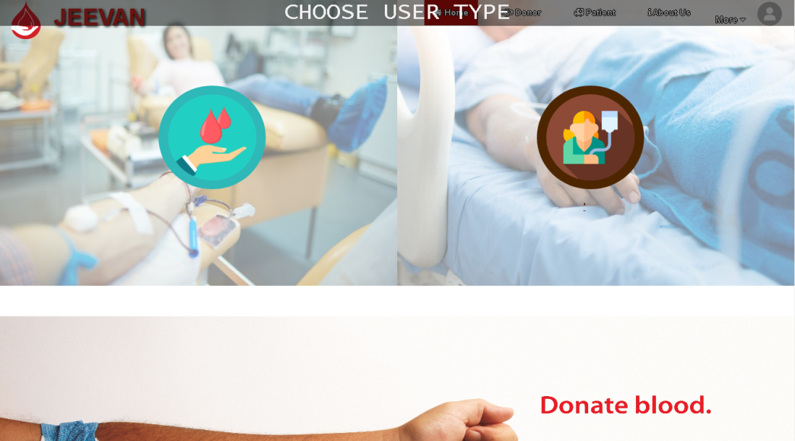

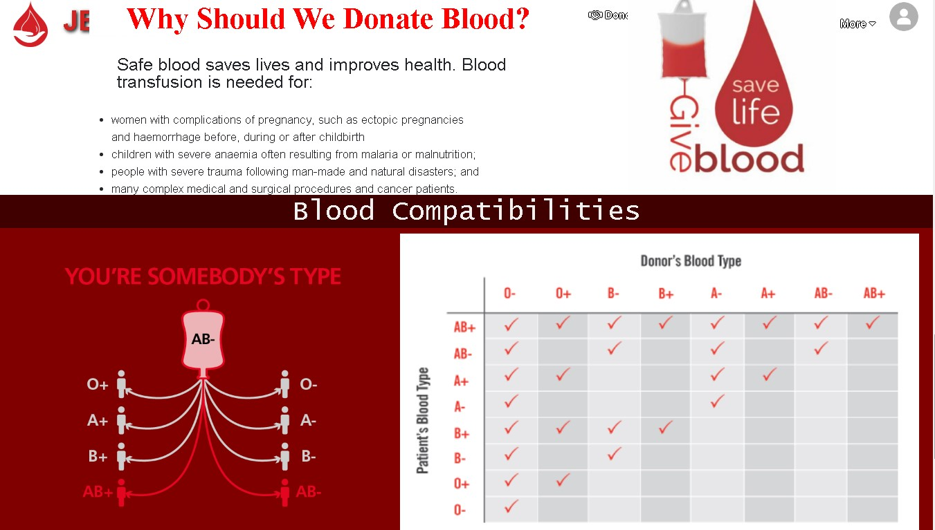

Fig 4.1 Homepage of “JEEVAN - Online Blood Donor Website”

**4.2. SURVEY FORM -** **JEEVAN** **AN ONLINE BLOOD DONOR WEB APPLICATION**

We used Simple html and CSS to create a survey form for donors taking some standard details from the WHO (World Health Organisation) guidelines for blood donation eligibility/suitability. This survey form utilises a JavaScript program to check the eligibility of prospective donors only if a donor is found eligible in accordance to the questions set on the basis of WHO guidelines for blood donation eligibility only then are they redirected to the donor registration form as seen in fig 4.3, if ineligible the users are redirected to the homepage with a pop up message as seen in fig 4.5. In fig 4.5 we can see the patient registration form where the patient can register or else, they can skip if there’s an emergency.

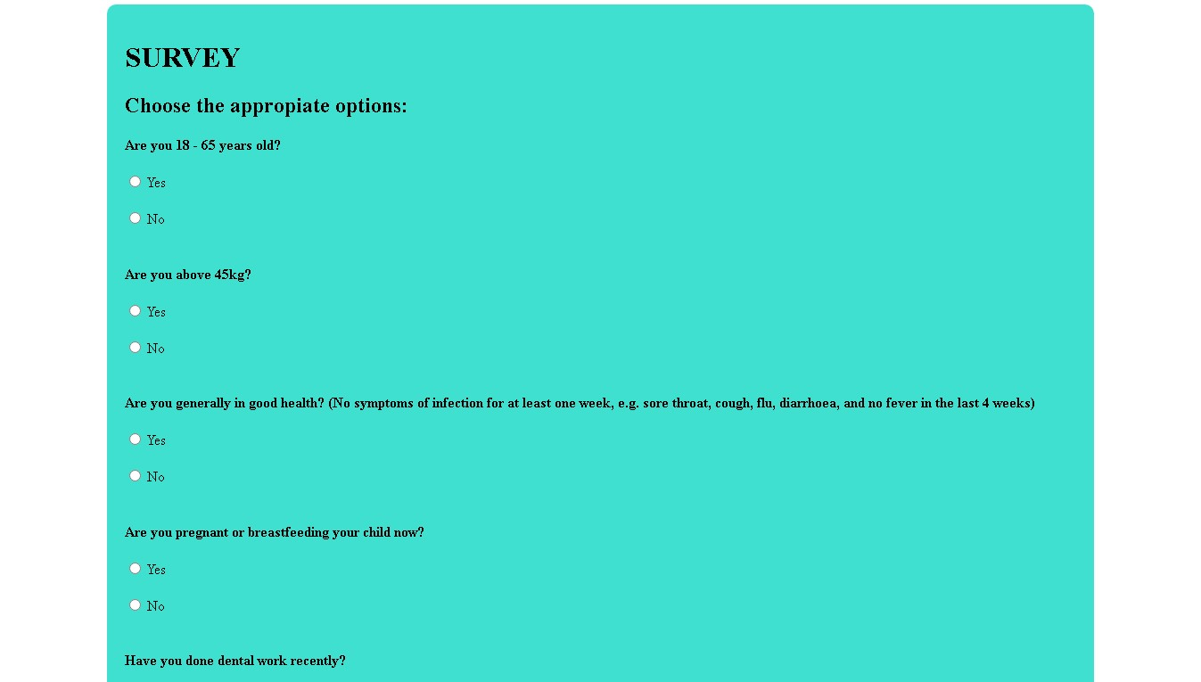

Fig.4.2 Survey form of “JEEVAN - Online Blood Donor Website”

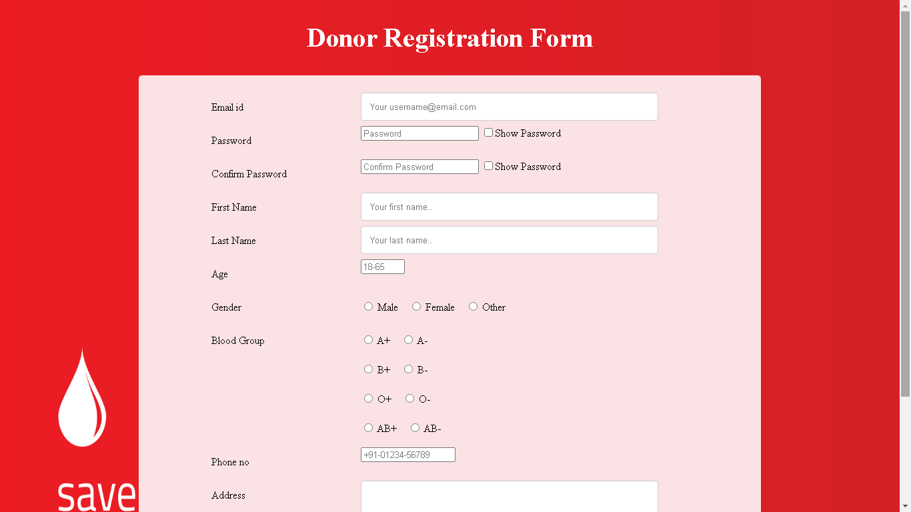

Fig.4.3 Donor Register form of “JEEVAN - Online Blood Donor Website”

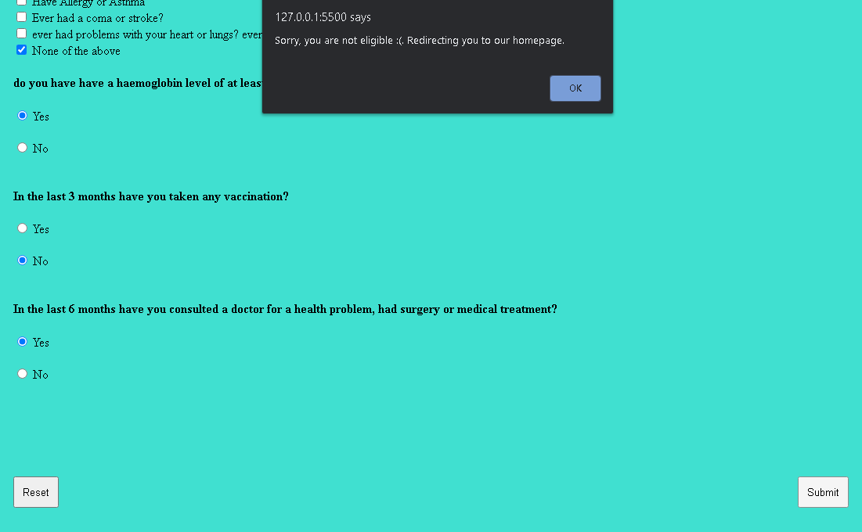

Fig.4.4 Ineligible for donor registration “JEEVAN - Online Blood Donor Website”

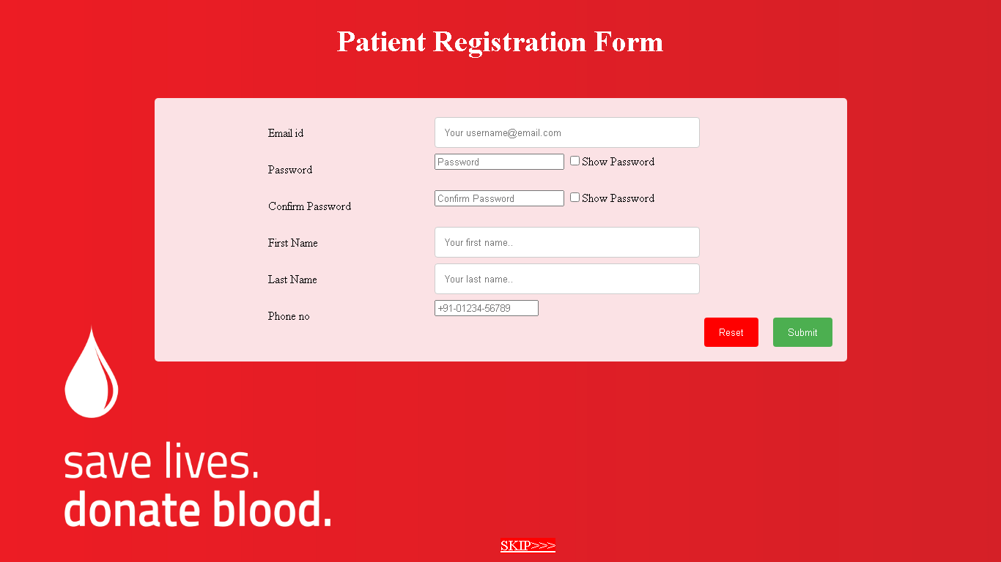

Fig.4.5 Patient Register form of “JEEVAN - Online Blood Donor Website”

**4.3. CHOOSE BLOOD CATEGORY -** **JEEVAN** **AN ONLINE BLOOD DONOR WEB APPLICATION**

In fig 4.6 on choosing any one of the blood categories the patient/user is redirected to a different html page containing the donors list that match the chosen blood type.

On clicking the post blood request button located in the same page users are navigated to the form as seen in fig 4.8 after filling and submitting the form their blood request will be posted and users can see that request on the view blood request option located in the home page.

On clicking the look for nearby blood banks button users are then navigated to a webpage which uses Google Map API to show the location of the nearest blood banks and their contact information currently this feature covers only the city of Guwahati but this feature can be scaled up as needed.

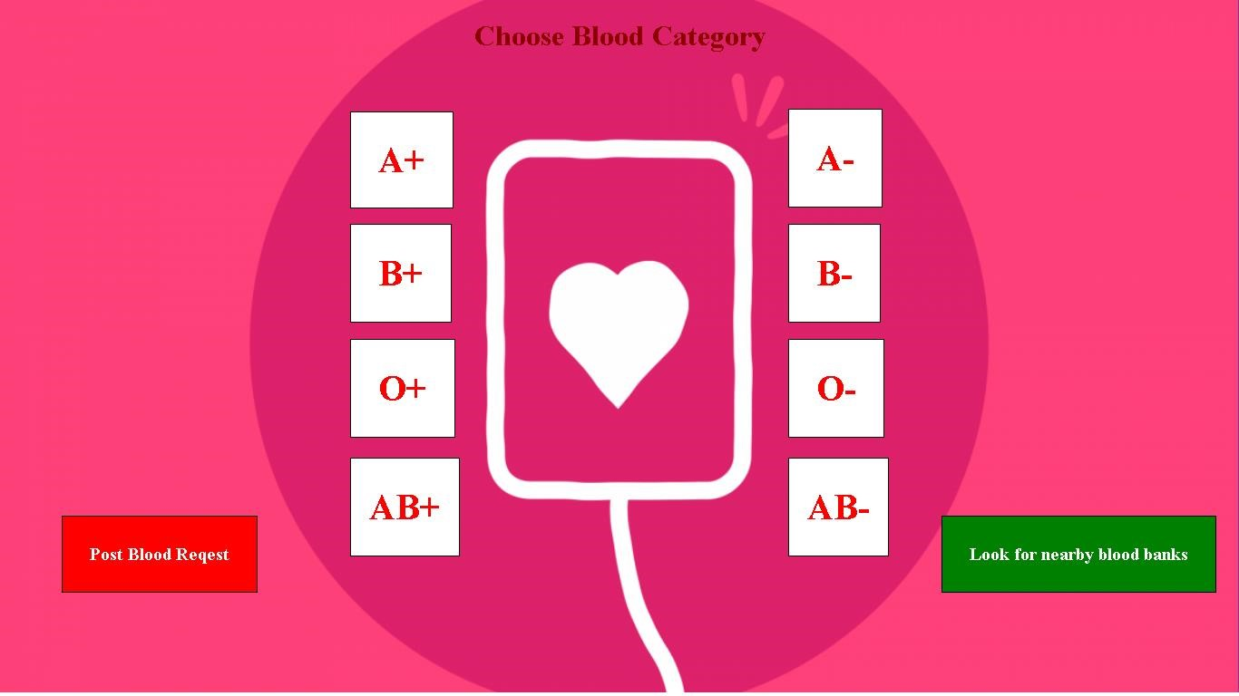

Fig.4.6 Blood Categories page of “JEEVAN - Online Blood Donor Website”

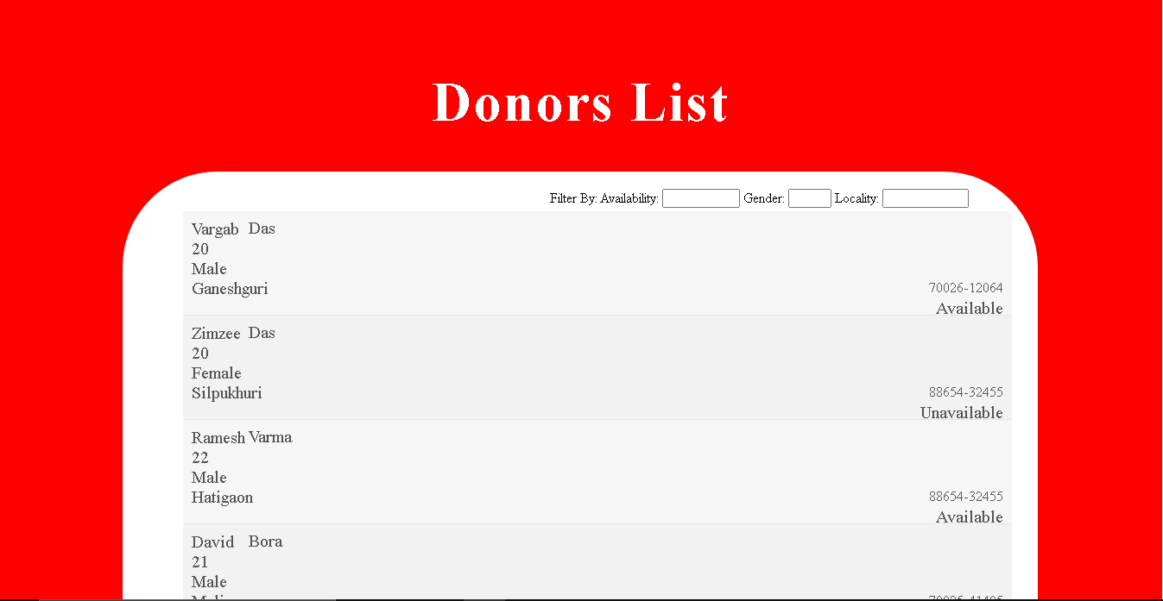

Fig.4.7 List of Donors page of “JEEVAN - Online Blood Donor Website”

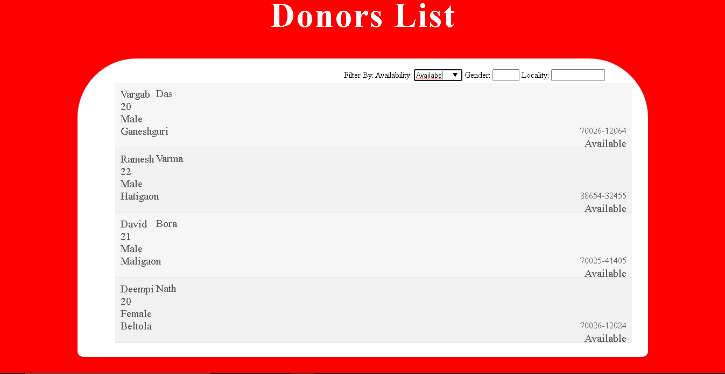

Fig.4.8 Filter Donors By Available

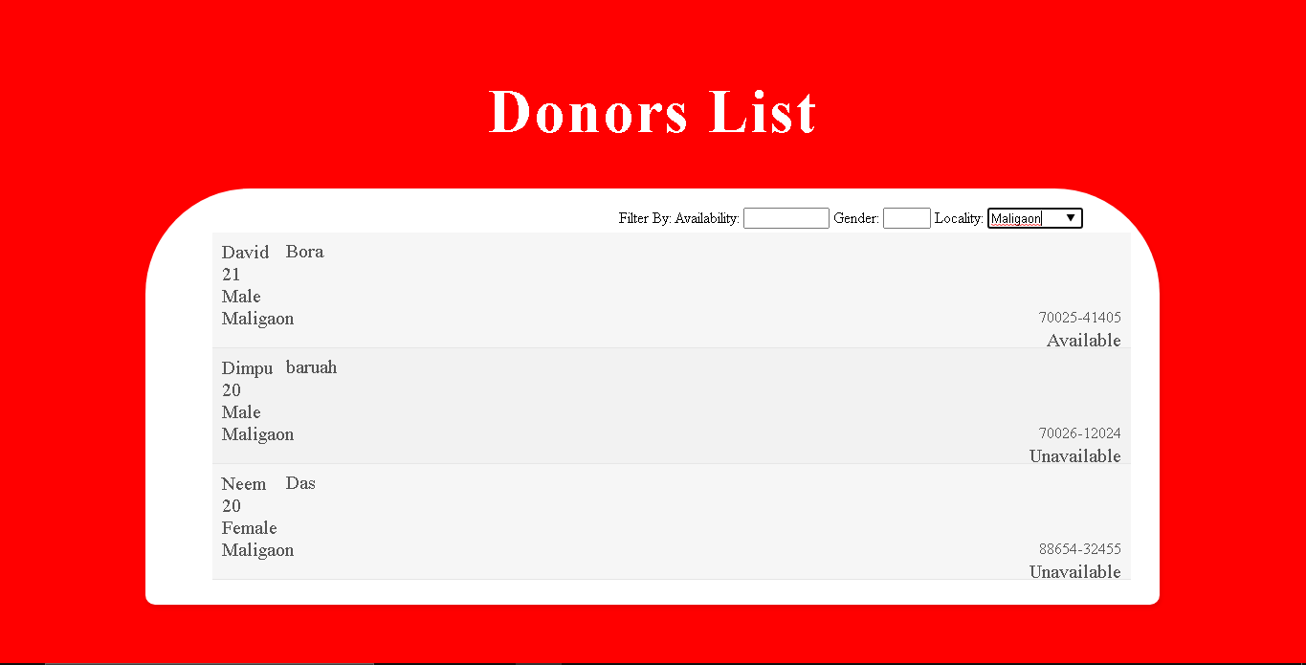

Fig.4.9 Filter Donors by Locality

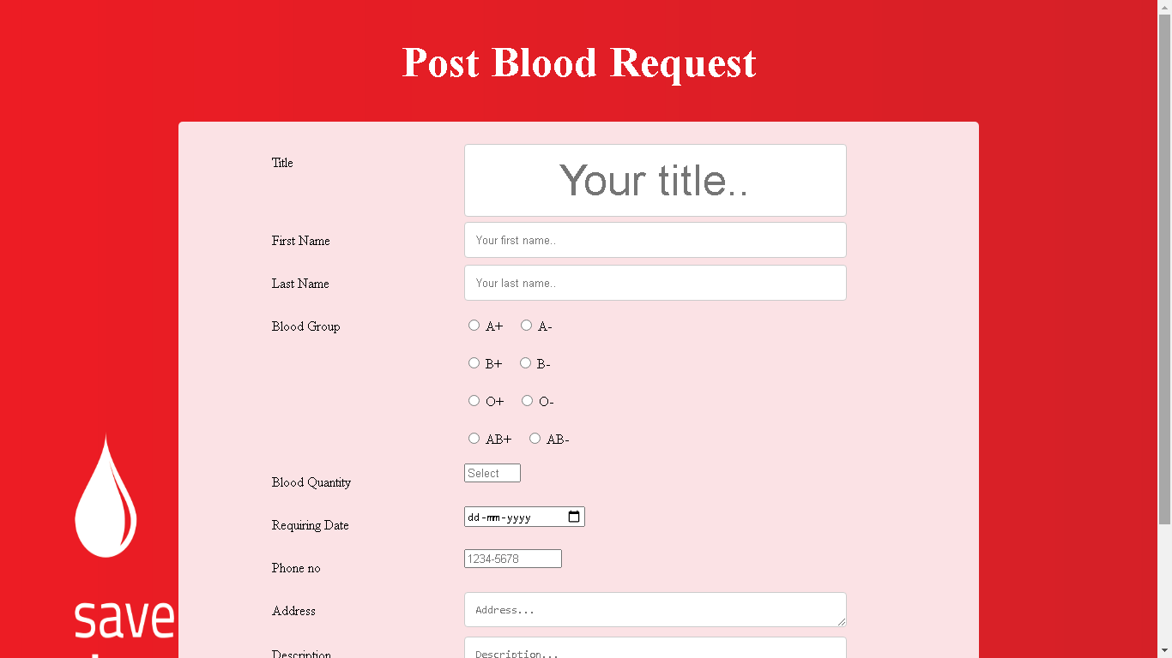

Fig.4.10 Post Blood Request page of “JEEVAN - Online Blood Donor Website”

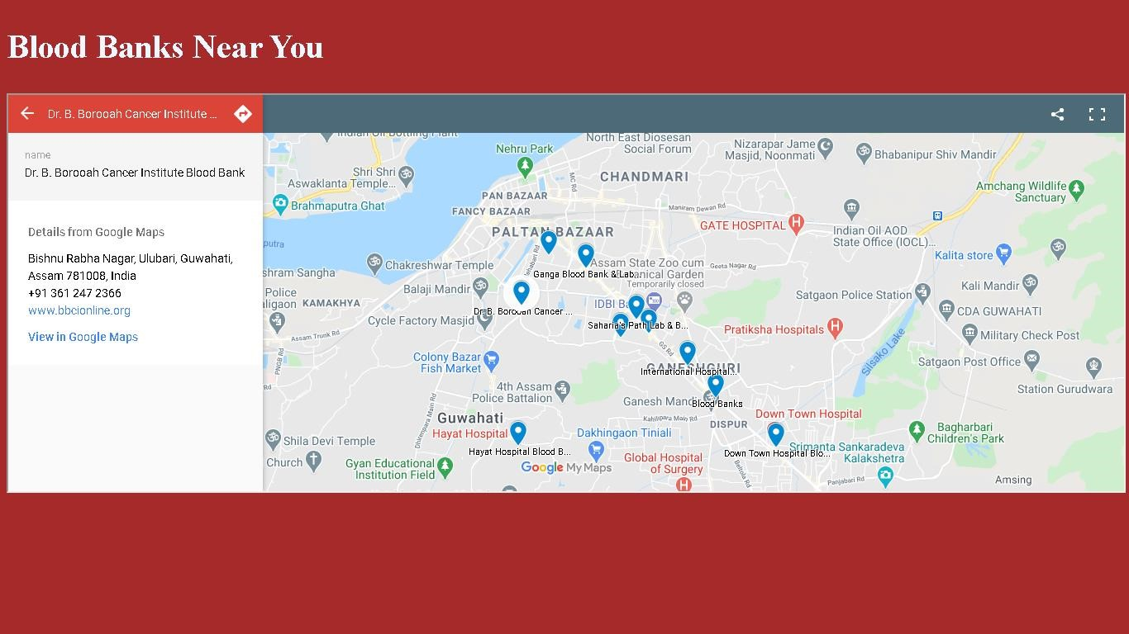

Fig.4.11. Finding nearest blood bank (MAP)

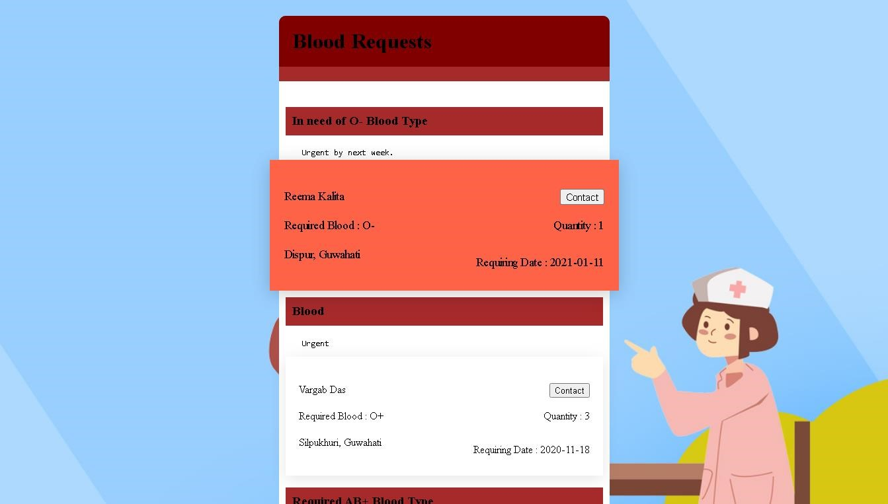

Fig.4.12. Blood Requests display page of “JEEVAN - Online Blood Donor Website”

**4.4. LOGIN PAGE -** **JEEVAN** **AN ONLINE BLOOD DONOR WEB APPLICATION**

The Login Page utilises Html, CSS, JavaScript and Bootstrap to allow users (Donor, Patient, and Admin) to login and go to their profile page .They can simply login using their email id and password. When a donor or a patient logs into the system their profile is opened containing their provided information at the time of registration and when an admin logs into the system he can monitor the donor, patient and can manage blood request .The data for the user’s profile are retrieved by a JavaScript from the firebase database on the clicking of the login button.



Fig.4.13 Donor/Patient/Admin Log In page of “JEEVAN - Online Blood Donor Website”

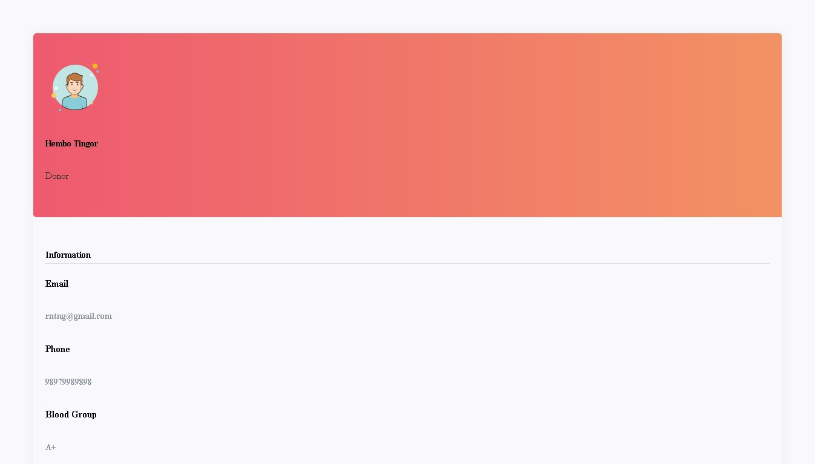

Fig.4.14 Profiles of donor & patients of “JEEVAN - Online Blood Donor Website”

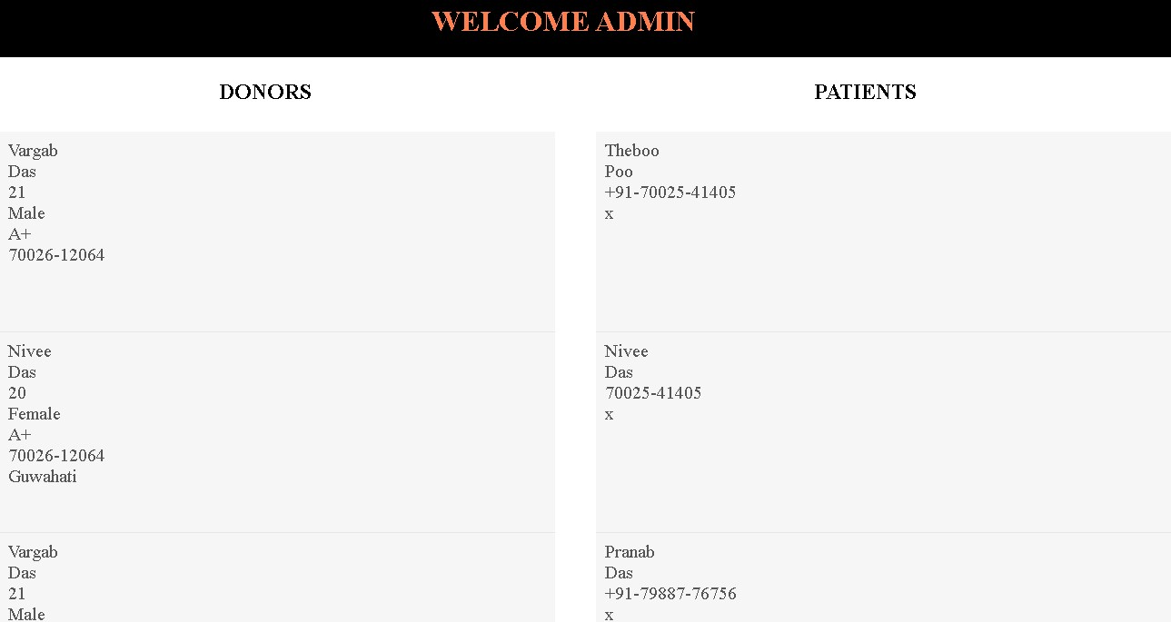

Fig.4.15 Admin monitoring donors and patients

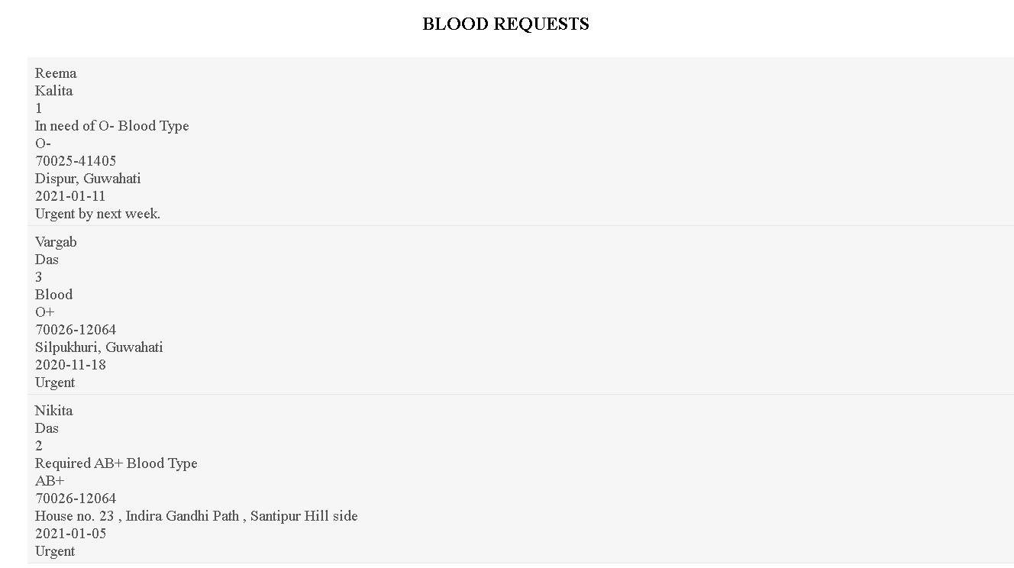

Fig.4.16. Admin monitoring blood requests.

**4.5. VALIDATION**

Validation check ensures data consistency and correctness in the system.

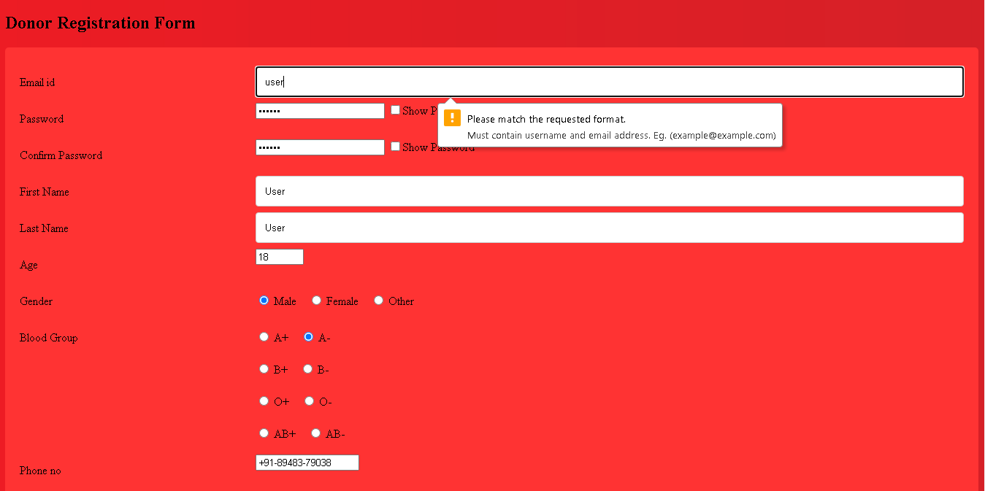

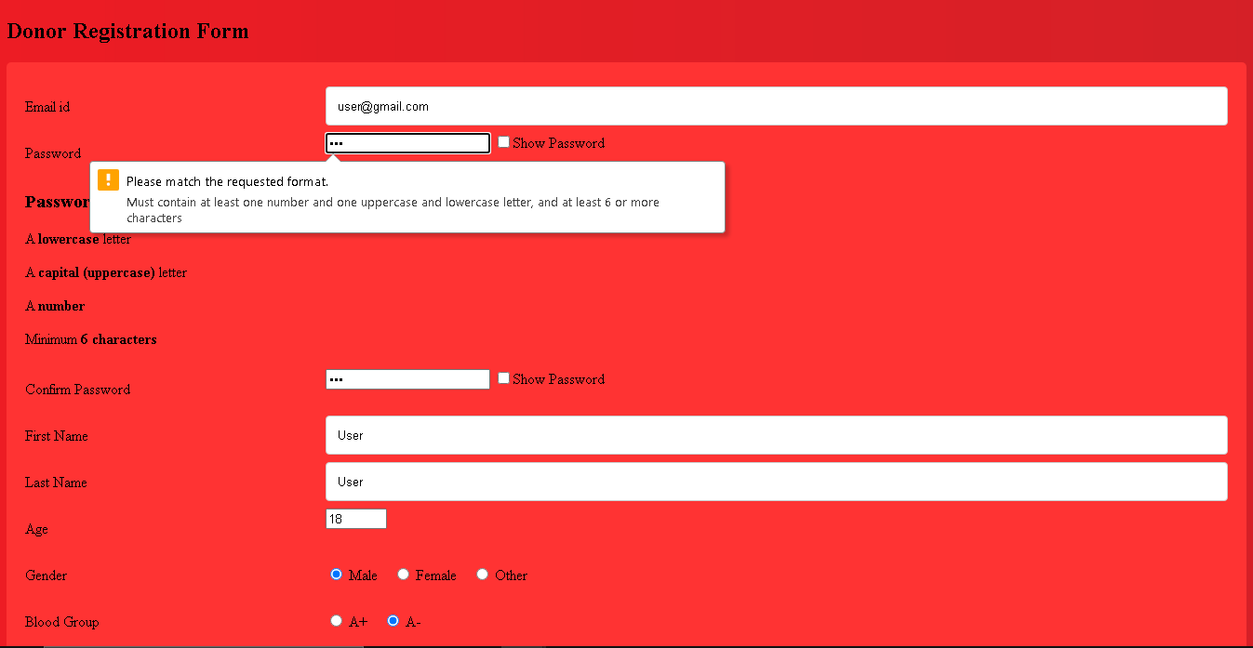

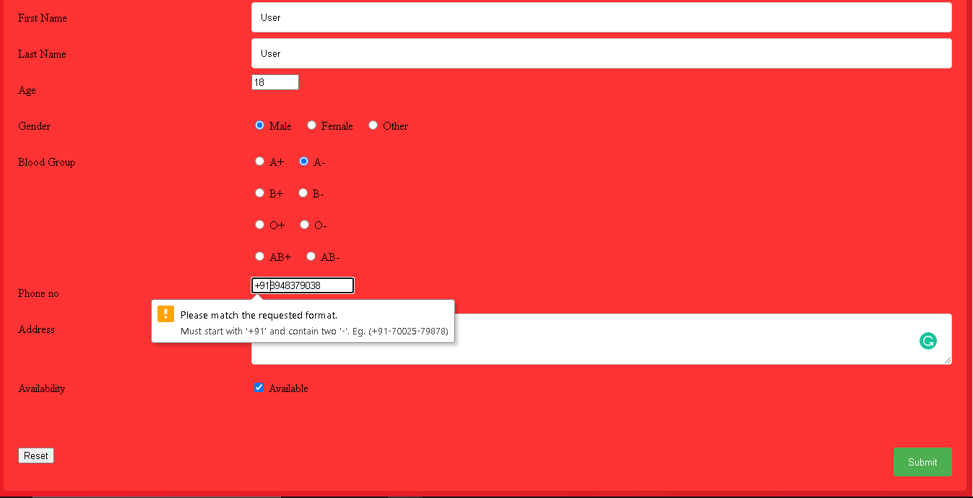

Fig 4.17 Donor Registration Validation

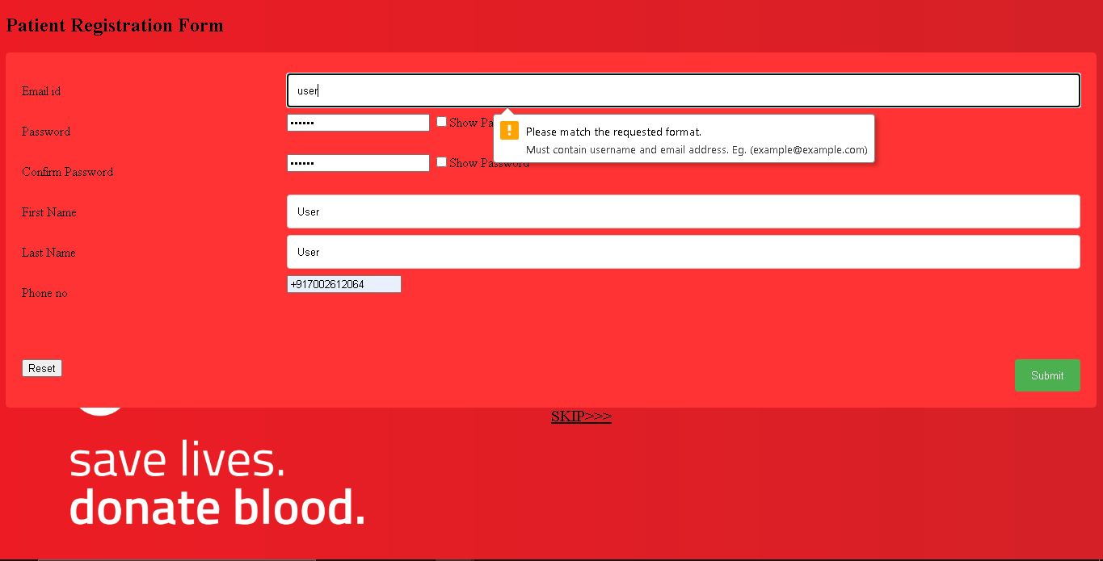

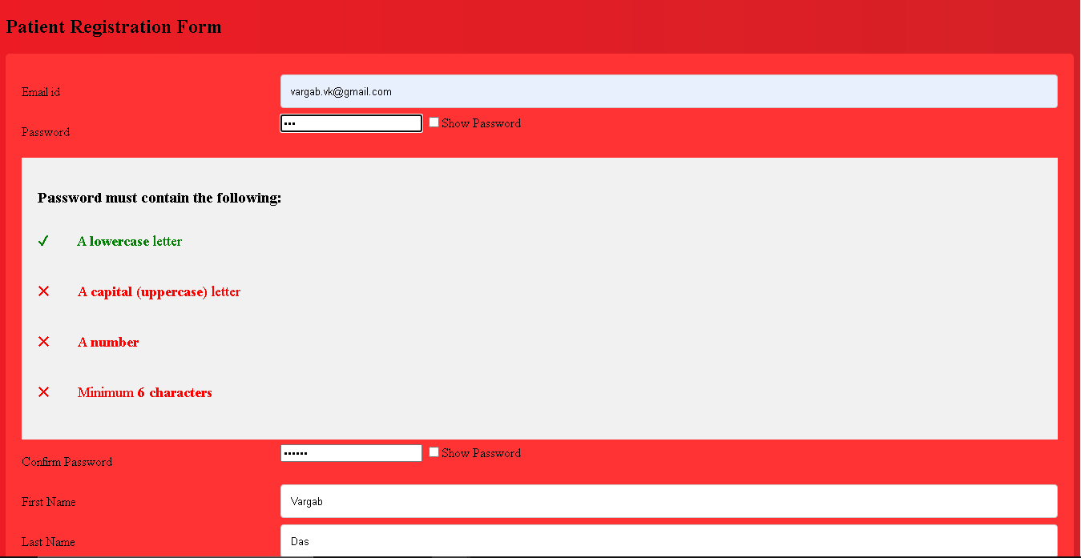

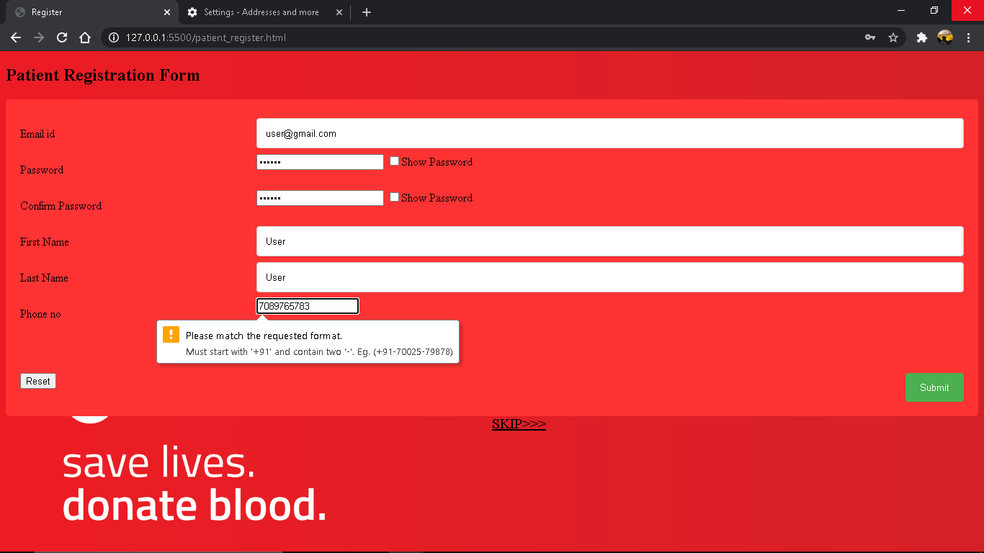

Fig 4.18 Patient Registration Validation

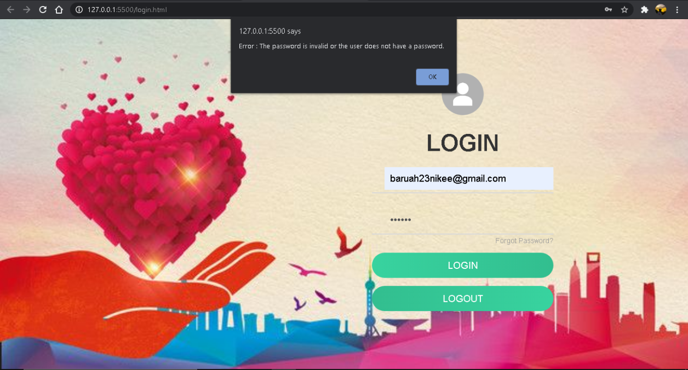

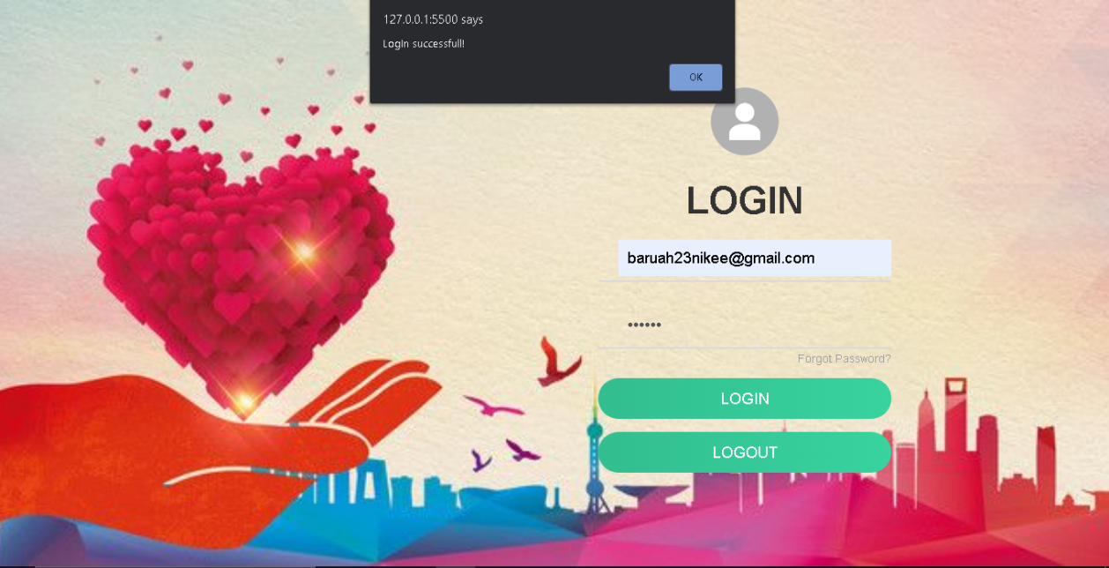

Fig 4.19 Log-in Page Validation

**4.6. Below figures shows what our website looks in mobile view.**

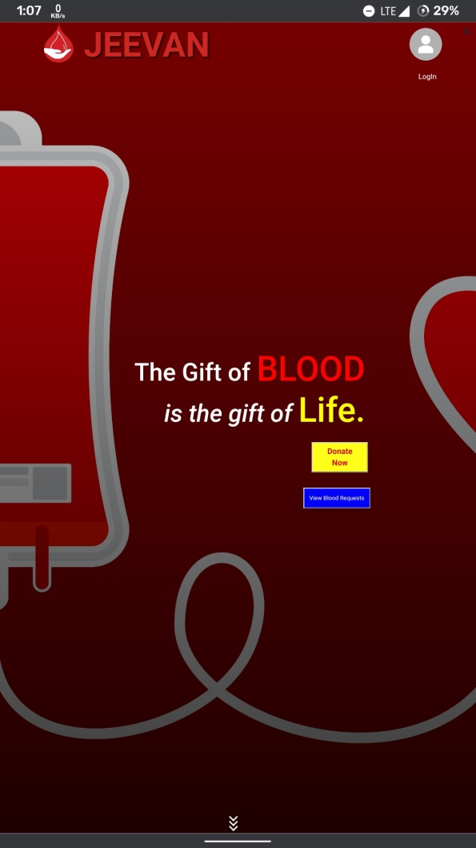 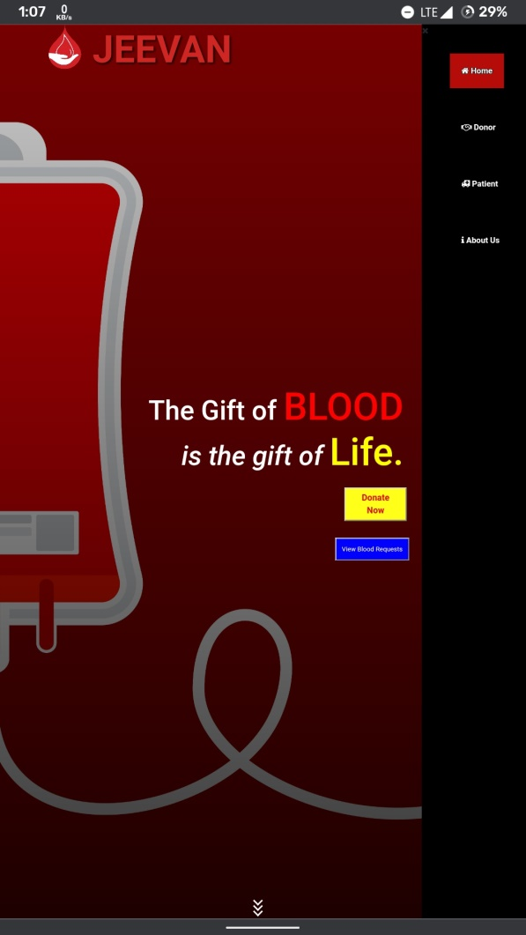

Fig 4.20 Homepage Mobile View

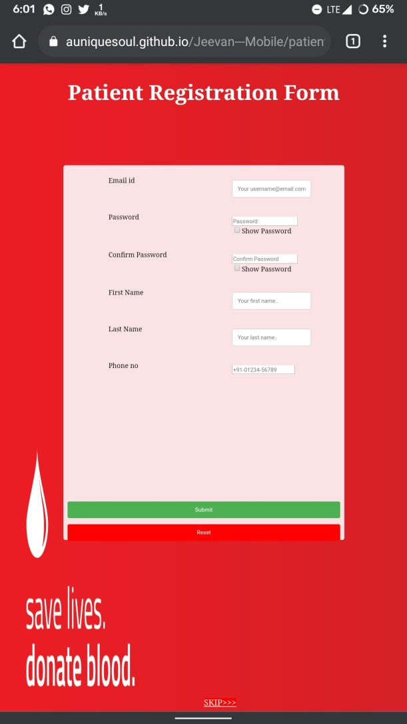 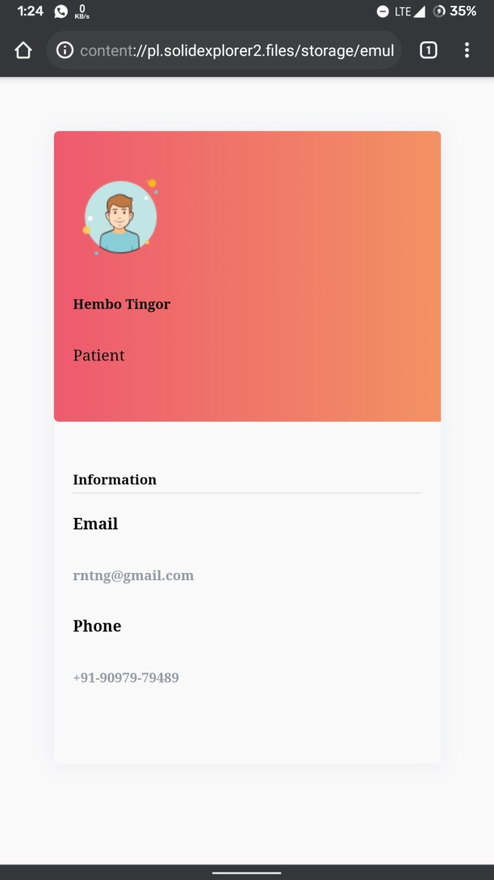

Fig 4.21 Donor Registration Mobile View Fig 4.22 User Profile Mobile View

**Chapter 5**

**CONCLUSION**

**5.1. SUMMARY**

As our project aims in helping and connecting the patients who are in need of blood and people who are willing to donate blood.

This project will provide a web application that will make:

1. Blood donation/receiving process easier.
2. Easier to Find a Donor of the required blood type just by simple searches.
3. Easier in making contact and staying connected with the donors via the contact information provided.

**5.2. Future Scope**

Our future work would be to:

1. Integrate this blood donor Web Application with hospitals & Blood Banks.
2. Enable direct communication between Donor and Blood Banks.
3. Adding the feature of filtering location to find nearest Blood Banks.
4. Improvement in the security level of the system.

**REFERENCES**

**Web links:**

* + 1. Existing System searches –

Blood Bank Today, https://bloodbanktoday.com

Friends 2 Support, https://www.friends2support.org/index.aspx

Indian Blood Donors, http://www.indianblooddonors.com

Eraktosh, https://www.eraktkosh.in

* + 1. Hardware Requirements –

Firebase FAQ, https://firebase.google.com/support/faq

PC Game Benchmark, <https://www.pcgamebenchmark.com/firebase-defence->system-requirements

[3]Software Requirements –

How to Firebase,

https://howtofirebase.com/what-is-firebase-fcb8614ba442

Tech Radar,

https://www.techradar.com/in/news/best-web-design-software

* 1. Work Breakdown Structure –

Work Breakdown Structure,

https://www.workbreakdownstructure.com

* 1. Gantt Chart -

Office TimeLine, [https://www.officetimeline.com/make](https://www.officetimeline.com/make-)ganttchart/excel

* 1. Diagrams -

Draw.io, https://app.diagrams.net

Medium, [https://medium.com/@smagid_allThings/uml-class](https://medium.com/@smagid_allThings/uml-class-)diagrams-tutorial step-by-step-520fd83b300

Visual Paradigm, https://www.visualparadigm.com/guide/uml-unified modelinglanguage/what-is-activity-diagram

Research Gate, https://www.researchgate.net/figure/A-Use-Case-diagram-of the-supply-chain-membersrelations_fig2_220938130

Stack Over Flow, https://stackoverflow.com/questions/1696927/whats-is-the difference-between-include-and-extend-in-use-case-diagram

[7] Implementation –

HTML, <https://www.w3schools.com/html/default.asp>

CSS, <https://www.w3schools.com/css/default.asp>

JavaScript, <https://www.w3schools.com/js/default.asp>

Survey Form for donor eligibility,

<https://www.who.int/bloodsafety/publications/bts_guideline_donor_suitability/en/> ( WORLD HEALTH ORGANISATION GUIDELINES FOR BLOOD DONOR SUITABILITY)

https://www.who.int/bloodsafety/publications/guide_selection_assessing_suitability.pdf